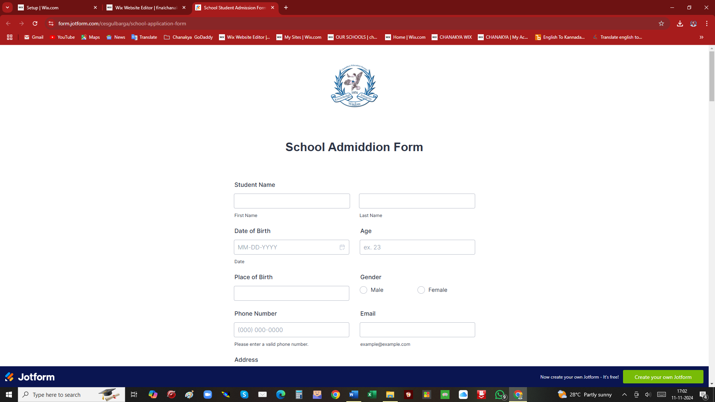
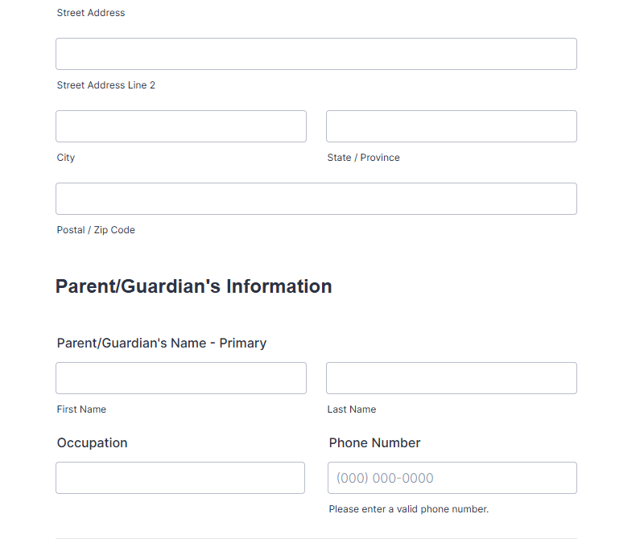
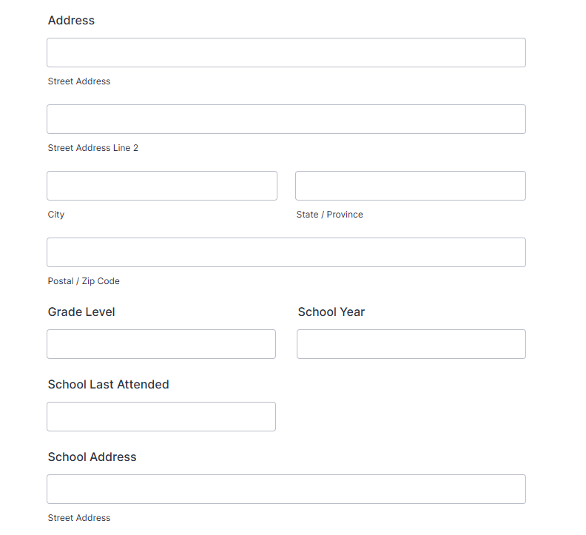
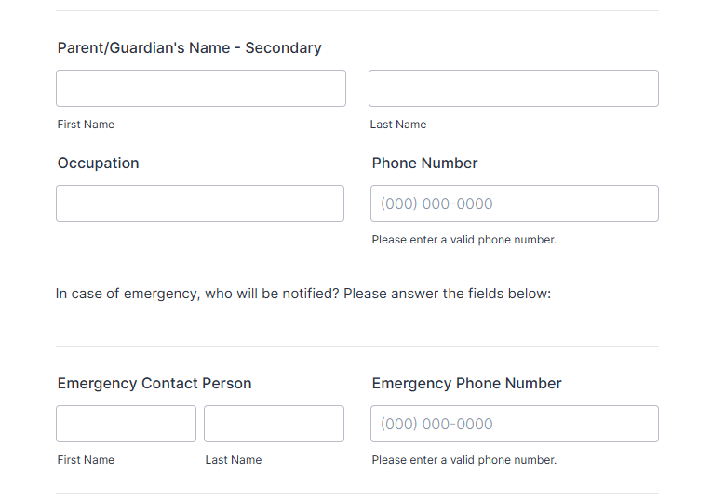

File to be attached
2x2 Colored ID Picture, birth certificate, report card from the previous school, certificate of good moral, and medical clearance.
Health History
- If the student have any allergies, please list them down below:

- Does the student currently taking any medications? If yes, please list them down below:

- Was the student previously hospitalized or undergo any surgery?
please list them down below:

- Does the student have any medical conditions that you would like to declare?
please list them down below:

Reminders
TEST. The school required new students or a transferee to take an exam in order to get admitted to the school.
INTERVIEW. The school admin will conduct an interview with the student as part of the screening test.
REQUIREMENTS. It is important to pass and complete all requirements before school starts. Failure to do so may delay the student from coming to school.
MEDICAL CLEARANCE. The school required all students to have a yearly physical exam. For new students, medical clearance for their doctor or school doctor is required.
BEHAVIOR. A certificate of good moral is required in order to get admitted to this school. Please request it from the previous school as soon as possible.

